21BDS0340

Abhinav Dinesh Srivatsa

Computer Networks Lab

Assignment – III

**Topology:**

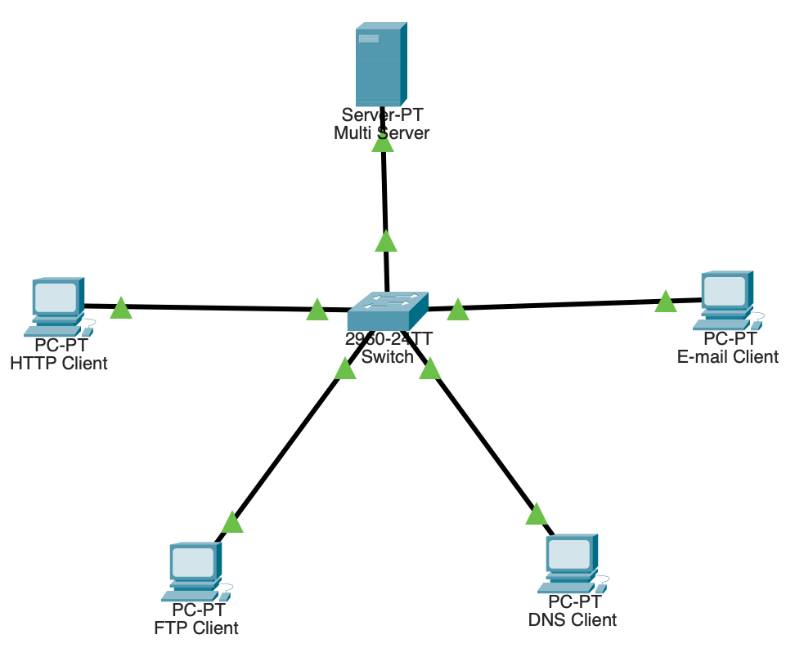

**Part 1**

Step 1:

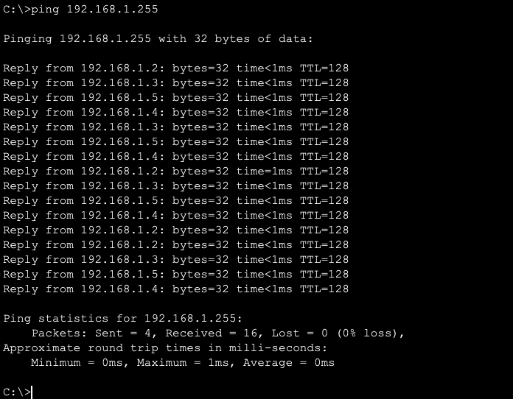

Step 2:

Step 3:

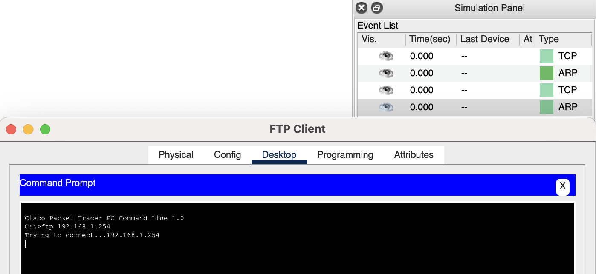

Step 4:

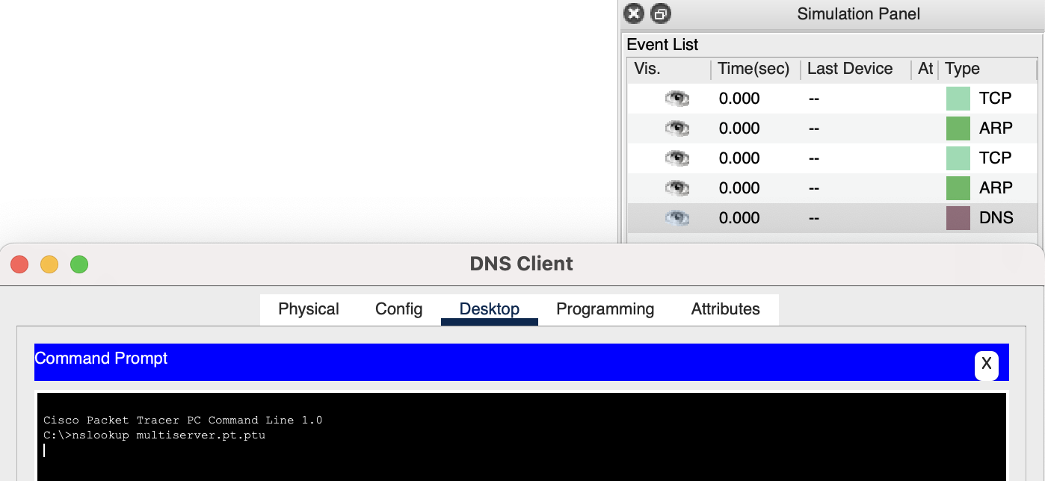

Step 5:

Configuring mail:

After sending email:

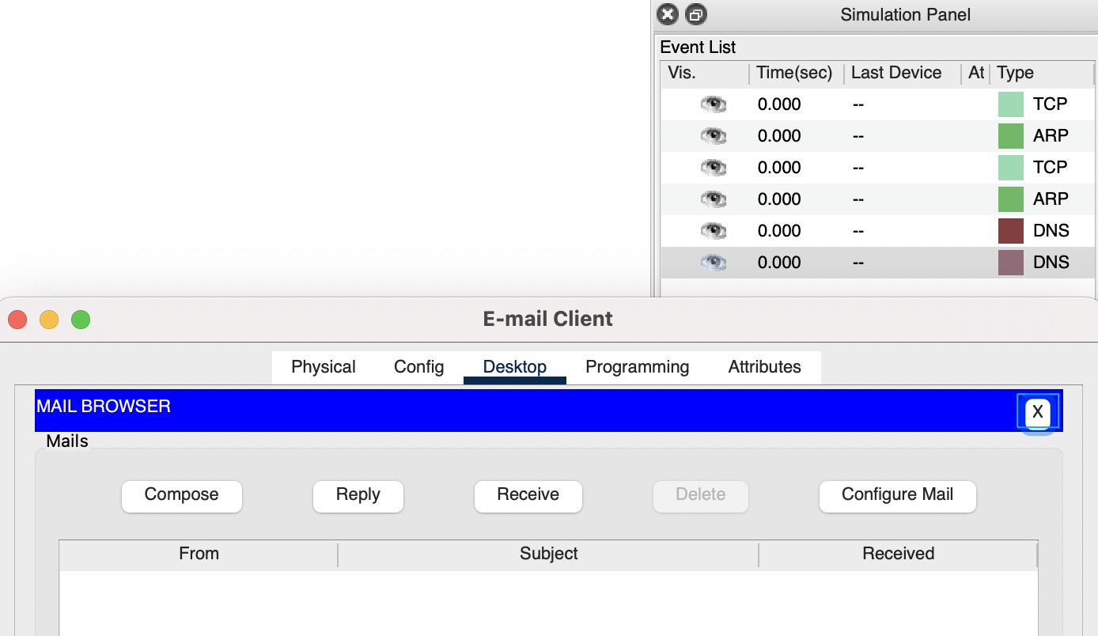

**Topology after creating PDUs:**

**Part 2**

Step 1:

1. Clicking Capture/Forward once:

1. Clicking Capture/Forward again. The PDUs that disappeared have been **resolved or have thrown an error**.

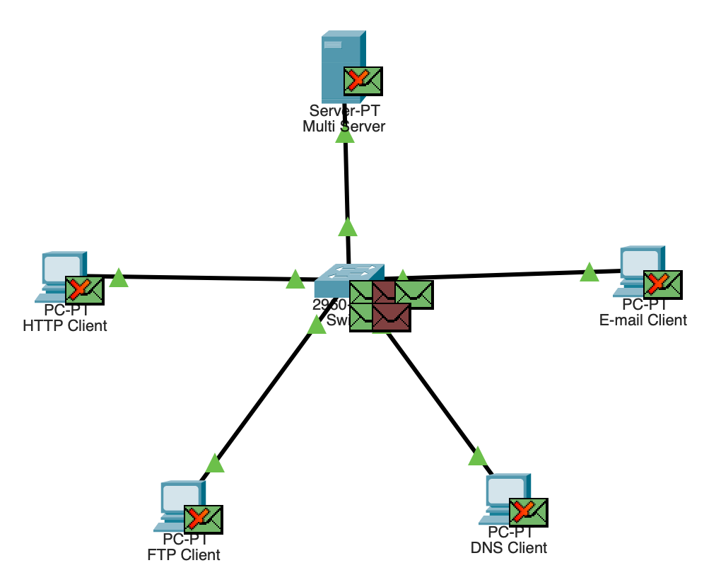

1. Clicking Capture/Forward 6 times. Each PDU can cross a specific wire at any given time, this happens because of **circuit switching**.

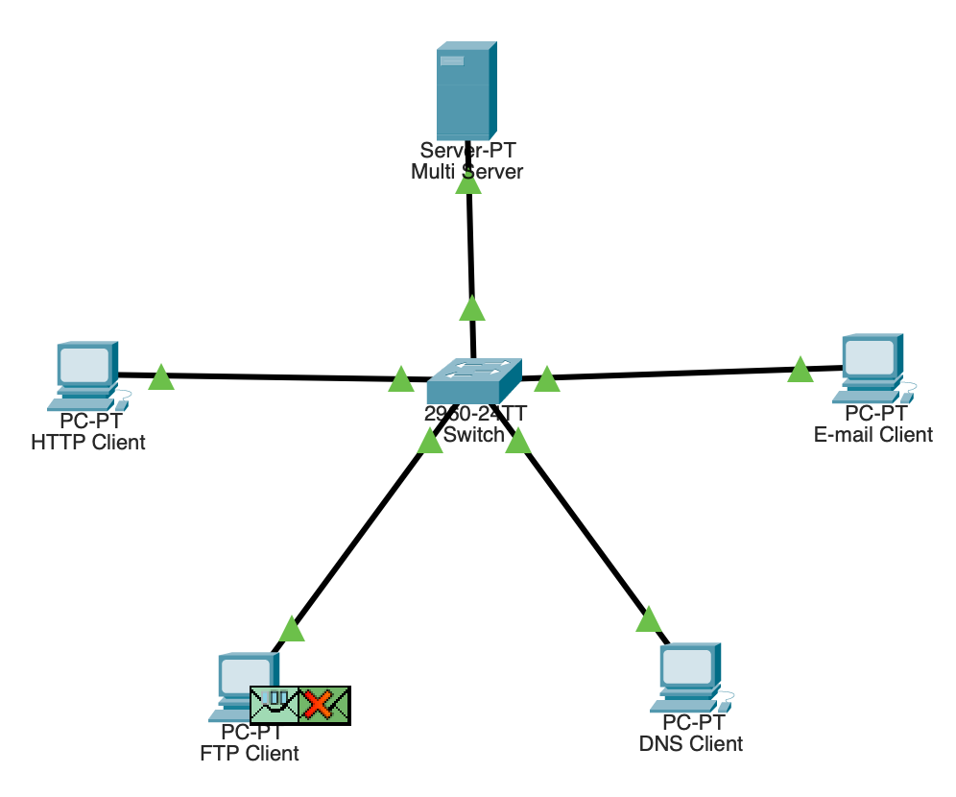

1. The different colours for the variety of PDUs are to represent **each type of request and response they serve**.
2. Clicking Back eight times.

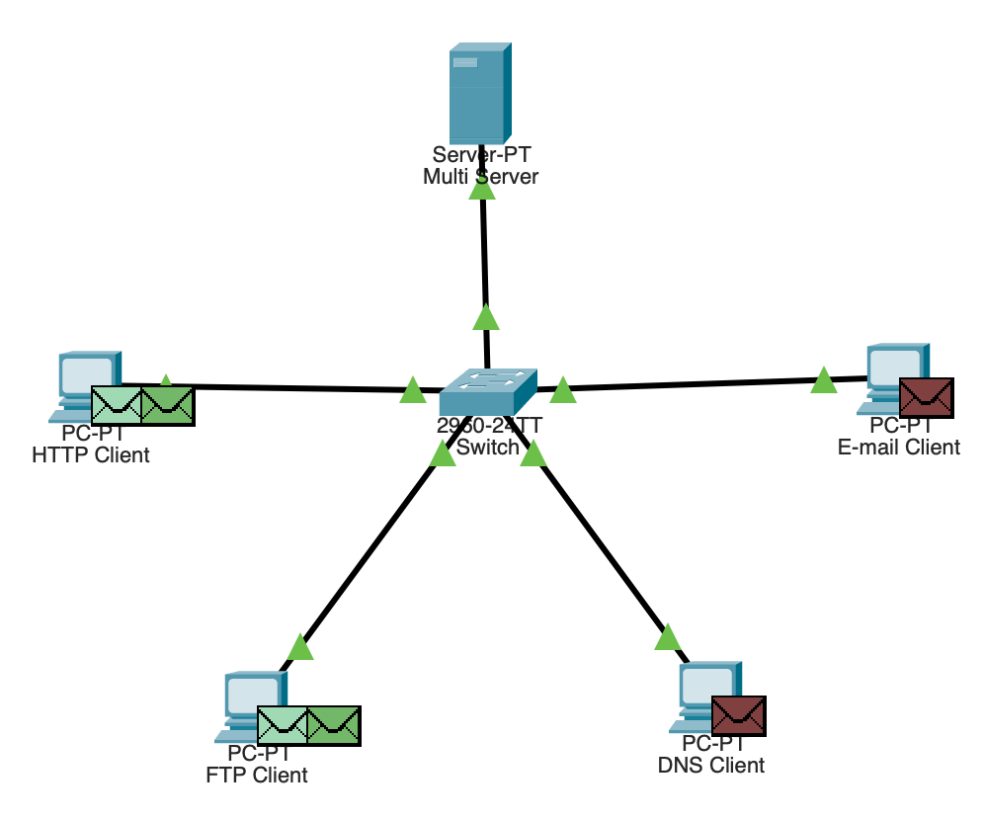

HTTP:

* The communication happens between the HTTP Client and the Multi Server, or IP addresses 192.168.1.2 and 192.168.1.254.
* The port communication happens on both server and client side through the port 80.
* Once the TCP request has been received by the server. The server will send back a HTTP fulfillment response and provide the data requested.

FTP:

* The communication happens between the FTP client and Multi Server, or IP addresses 192.168.1.3 and 192.168.1.254.
* The port communication happens on both the server and client side through the port 21.
* Once the TCP request has been received by the server. The server will send back an FTP fulfillment response and provide the data requested.

DNS:

* The communication happens between the DNS client and Multi Server, or IP addresses 192.168.1.4 and 192.168.1.254.
* The port communication happens on both the server and client side through the port 53.
* Once the TCP request has been received by the server. The server will send back a DNS fulfillment response and provide the data requested.

SMTP:

* The communication happens between the DNS client and Multi Server, or IP addresses 192.168.1.5 and 192.168.1.254.
* The port communication happens on both the server and client side through the port 25.
* Once the TCP request has been received by the server. The server will send back a SMTP fulfillment response and provide the data requested.

**Result:**

I have now understood a few basic transfer protocols that use TCP and UDP connections to initiate and create connections between computers. This is the basis of the internet, and I have demonstrated this in a simulated LAN on Cisco Packet Tracer.